Grand Proposal Management System (GPMS) Testing
Under Milson Munakami

Nicholas Chapa
Computer Science
REU Software Security
Boise, US
nicholaschapa@u.boisestate.edu
Liliana Acevedo
Computer Science
Humboldt State University
Arcata, CA, USA
Lva34@humboldt.edu

Abstract—The Grant Proposal Management System (GPMS) is a secure web-based workflow management system that uses ABAC (Attribute-Based Access Control). ABAC is a fine-grained access control model in which attributes, such as position type or title are used to restrict access for who can do what, how and when. In contrast to time-consuming and tedious manual testing, test automation tools such as Selenium allow verification of all possible workflow scenarios in a repeatable manner. Testing of the GPMS requires black box testing of software functional requirements as well as policy-based security implementation. Our testing methodology uses a combination of Selenium IDE, Selenium WebDriver, and JUnit. Selenium IDE is a Firefox browser plugin that records user actions on the visible aspects of an application. On the other hand, Selenium WebDriver is an Object-Oriented API allowing test cases for hidden web elements. The use of logic in each test case along with the overall flow of information allows for testing of a secure workflow application. (Abstract)
Keywords—access control; automated testing; functional testing (key words)

Introduction (Heading 1)
The project focused on in this paper is the testing of a web based application of a grant proposal management system (GPMS). This system was developed by Graduate student Milson Munakami and is designed to take the place of paper project proposals while becoming easier to use and faster to share with necessary faculty. Currently the GPMS is meant for use on a college campus and is optimized for that purpose.
When applying for funding for research work a PI will generally complete an OSP Grant Proposal sheet. This paper documents all the specifics of the research work that requires funding. This includes pay rates, budgets, lab space, and any test subjects that may be used, as well as if the proposal includes any Co-PI’s or Senior Personal. This paper must then receive signatures and approvals from various faculty members and administration in order for it to be submitted for funding consideration. First the PI, Co-PI(s), and Senior personal must sign for the proposal to be submitted to the Department Chair. The Chair will then sign and approve or disapprove the proposal. Upon his approval the proposal then goes to the Business Manager, Dean, and IRB if test subjects are to be used in the research. Each of these faculty members must sign and approve (or disapprove) the proposal for it to go to the administration. Next the Research Administrator receives the proposal and must fill out the OSP section of the proposal before signing and approving or disapproving the proposal. The Research Director then receives the proposal and signs then may approve, disapprove, delete, withdraw, or archive the proposal as they see fit. If approved the proposal returns to the Research administrator who can then submit the proposal for funding evaluation.
As one can see there is many steps to getting a proposal submitted. Each faculty member must be physically approached
Since the website has already been built my partner and I are only testing it to ensure it functions properly. This is the most important aspect of this project as these tests must confirm a wide variety of rules to ensure that accessibility to proposals is controlled. Which is why the main goal of the tests is access control.
Following is an image of a traditional grant proposal sheet
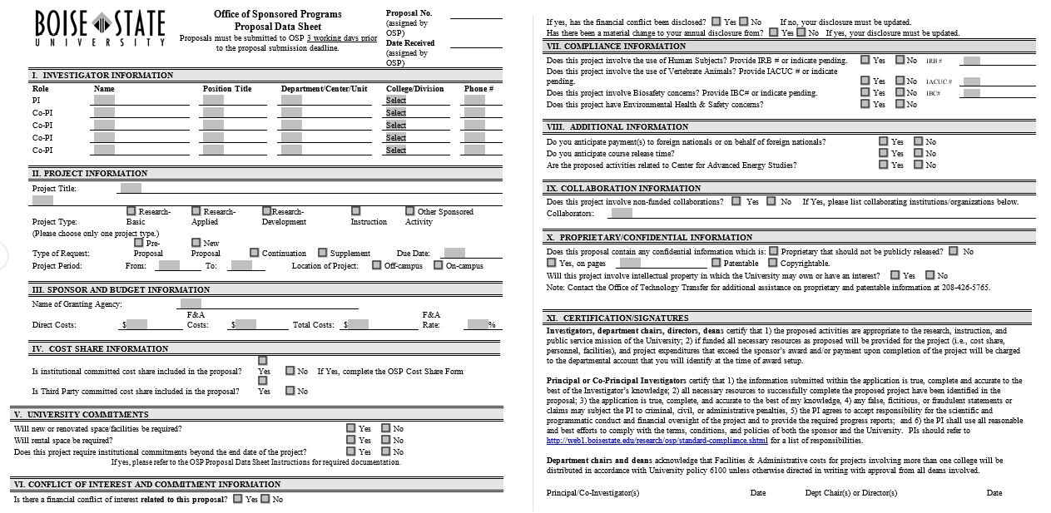

Testing Methods

User Interactions
How a user will be interacting with the GPMS website is integral to this project. Thus our tests center on replicating and repeating the actions that a user of the system would perform. This way we are able to test every scenario of actions that a user may perform with the system. The reason for this method of testing is too keep the limits of our actions on the system within the same limits a user would have thus, more accurately reflecting how a user might use the system. To specify what these interactions would be Milson and his fellow graduate students wrote up a list of 54 rules that the GPMS has to follow in order for it to be successful. Most of the rules are guidelines for how proposals can be submitted, the order in which faculty can approve them, and the actions each faculty/proposal member is allowed to perform. Following is a sample of a few of the rules GPMS follows.
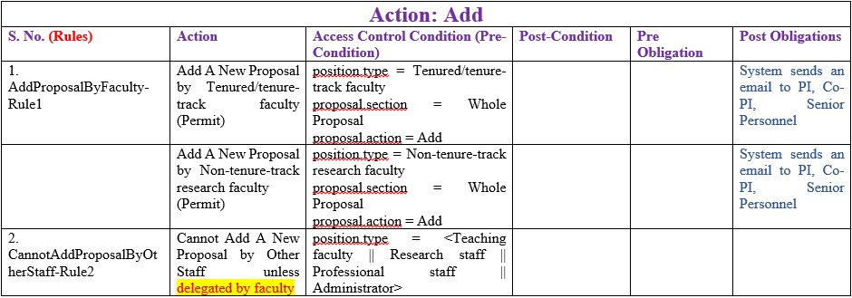

Tools used
While it is not the main focus of this paper I feel it is important to bring attention to the tools and programs used in this project. Namely the Selenim IDE which saved us a great deal of time in making test cases by allowing us to record website actions (mouse clicks, keystrokes) and replay them. Mozilla Firefox and google Chrome were the web browsers used for their speed and popularity. For writing of longer test cases and fine tuning code we used Mars Eclipse. In order to use our test cases with google Chrome we also used chromedriver which also helped to automate our tests. Upon each successful test the details and results of the test were recorded in a spreadsheet. This way we could keep a detailed account of what a test did, the parameters, expected outcomes, and end result. Following is an image of the Selenium IDE and a view of the documentation of the rules tested.
Identify applicable sponsor/s here. If no sponsors, delete this text box (sponsors).

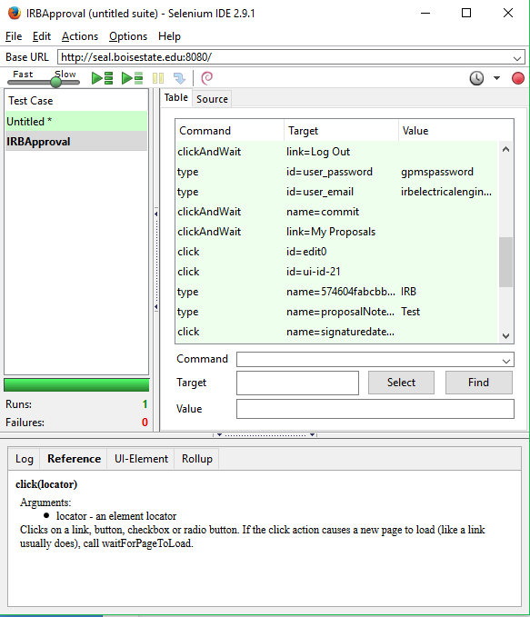

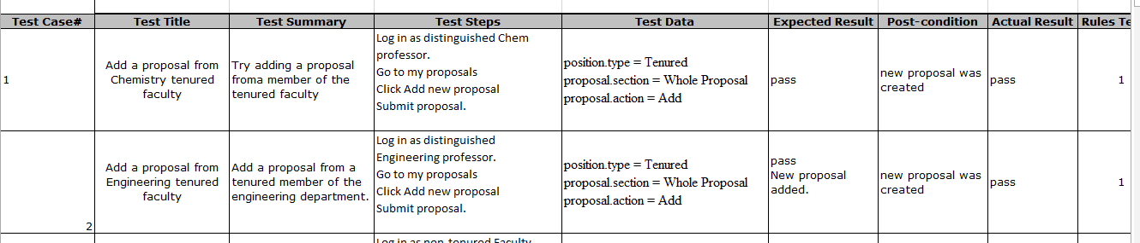

Relevence
The greatest benefit for using a web based application to replace paper proposals is the added convenience. Instead of needing to physically bring the proposal to each faculty member needed to get the proposal approved or declined faculty can instead log into a website to review the proposal at their own convenience and get notifications about the proposal’s status by email. This also removes the risk of a paper proposal becoming misplaced or lost by accident.

Websites accessibility
The GPMS system can be accessed from any web browser as long as there is internet access (obviously). It can also be accessed from smart phones and tablets with all of the functionality as if the site had been accessed from a computer. Following is an image of a paper project proposal sheet.

Ease of Communication
With the GPMS website updates about the proposals status can be sent automatically to any and all faculty involved in the approval of the proposal. Multiple emails can be added to their account for notifications to be sent to. The website itself will show notifications about proposal statuses.

Ease of Modifying Personal
The GPMS website makes the adding and removeing of personal very simple. Any personal who are authorized may simply log in and add or remove Co-PIs or senior personal. However, personal can only be modified before the proposal is submitted.

Conclusion

Bugs and Issues Encountered
For the majority of this project the issues we encountered were fairly minimal. However we did run into multiple difficulties throughout the summer. The biggest issue we encountered was losing access to the GPMS website when Milson was modifying the coding of the website. Another issue was multiple times needing to re-write code after the variable names of website text boxes and buttons were changed. Without re-writing the code none of the test cases would work as the variables and object being searched for no longer existed. We had another issue with selenium not being able to perform hover actions on the website during a test case. This caused quite a few issues as many major website interaction icons could only be triggered by hovering over them.

Summary
To summaries, the main benefit of this GPMS website is the added convenience it gives to faculty and administrators when reviewing a proposal. Since the website can be accessed from any web browser enabled device faculty can review proposal changes and make their own from the comfort of their home or anytime they are away from their office. This added convenience should make it much faster and simpler to create, submit, and receive signatures on a proposal so that it can be finished and submitted by the Research Administrator much faster. In the future it is possible that this website could be modified for use with other previously paper proposal sheets or other documents requiring multiple signatures. However the benefits of the current GPMS website must first be seen before any major modifications should take place.

